* Contianer are by default connected to each other.
* Ifconfig to see ip address for the container
* Ip addr
* 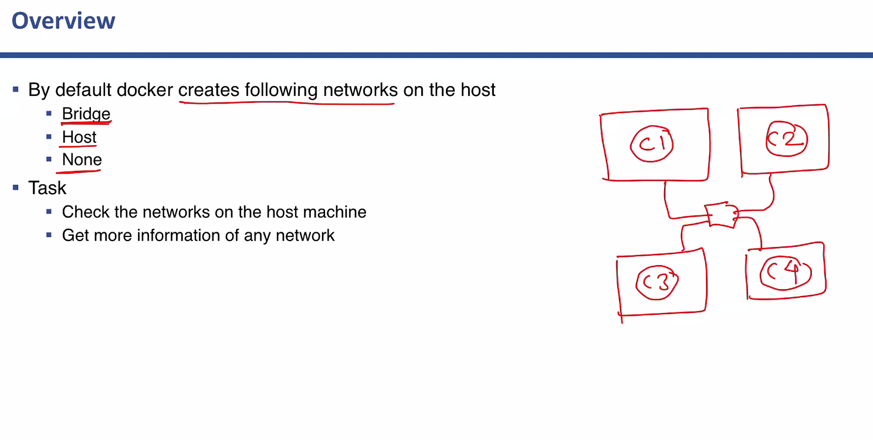
* 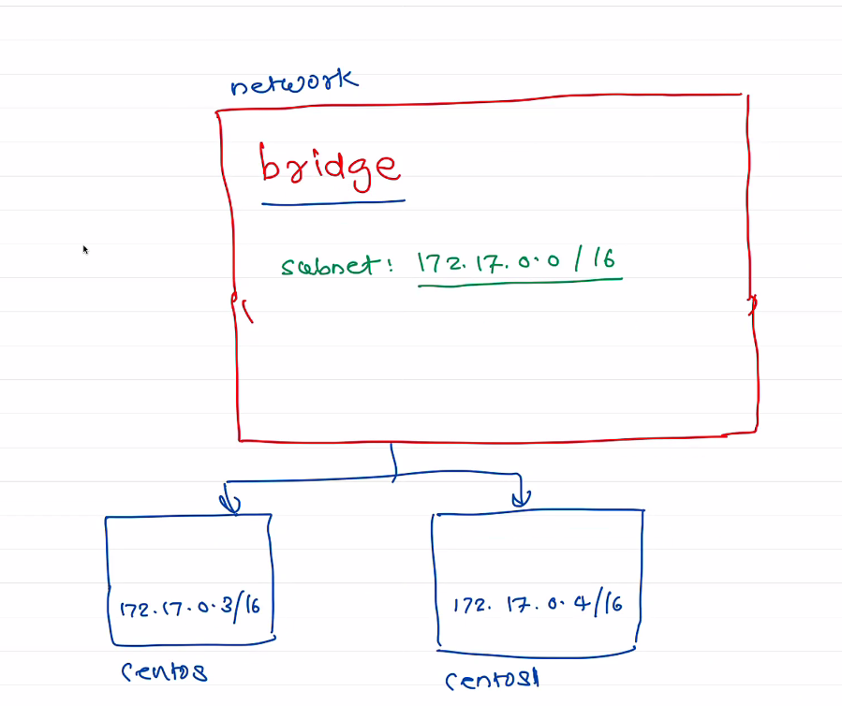
* 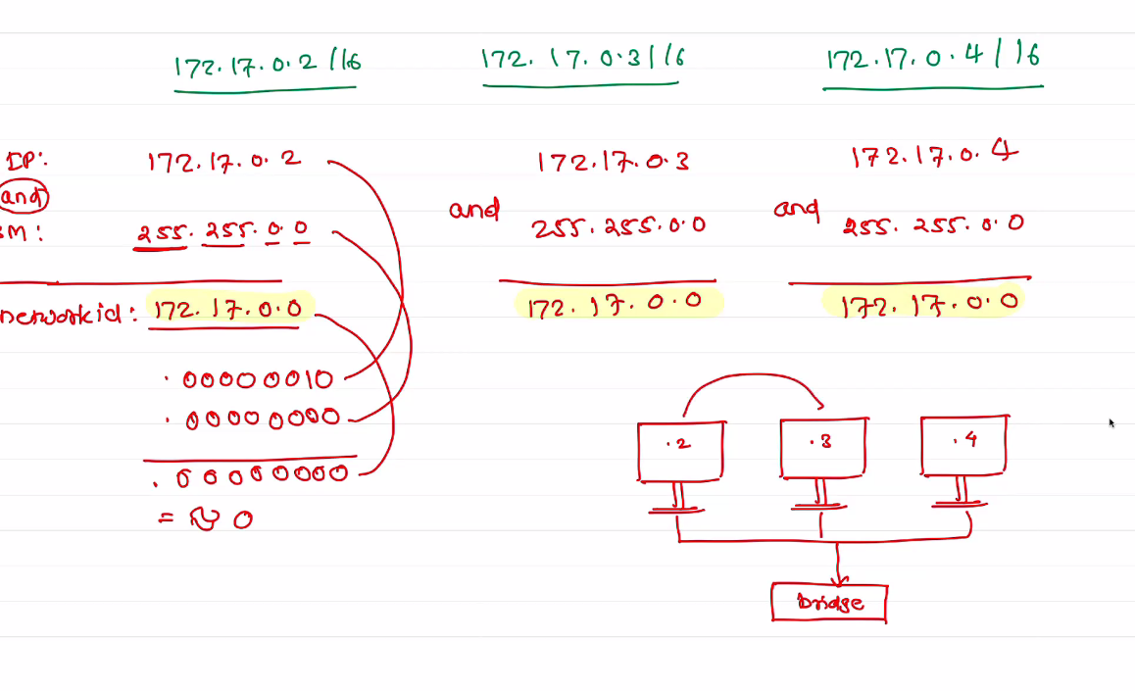
* Create a custom network for front end and back end application.
* 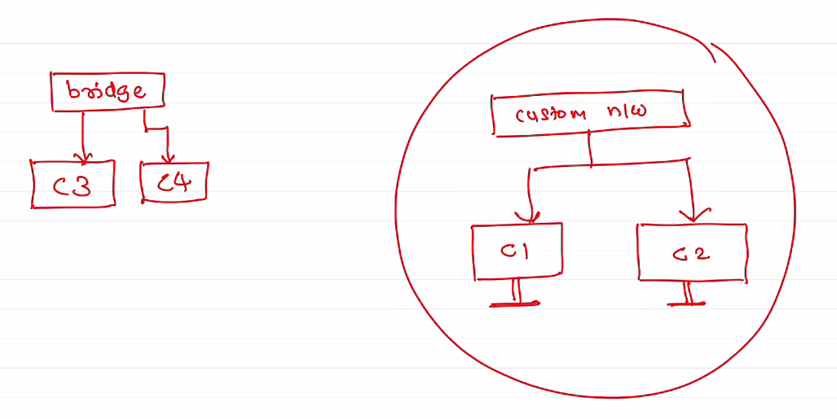
* 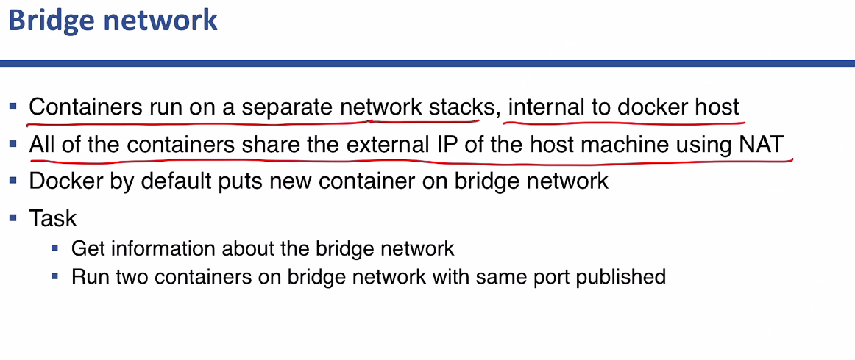
* 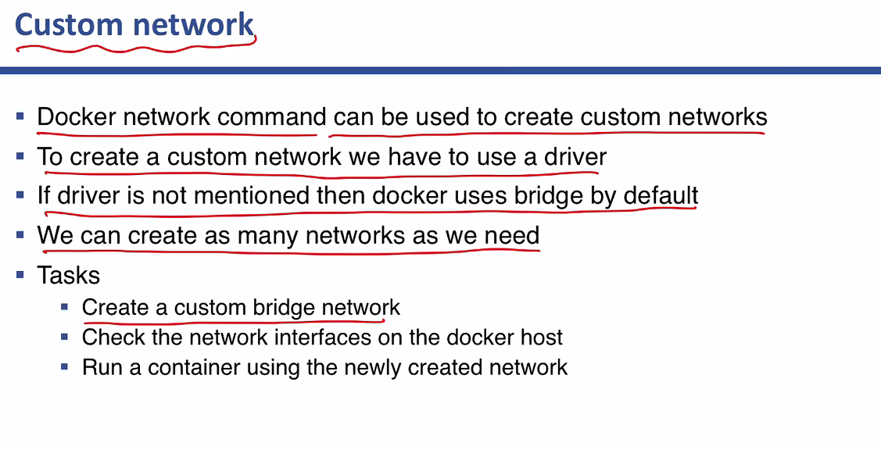
* > docker network ls
* > docker network inspect bridge
* > docker network create --subnet 192.168.1.0/24 mybridge
* > docker network create --subnet 192.168.1.0/24 --driver bridge mybridge
* > docker network rm mybridge
* > docker container run -itd --name c3 --network mybridge alpine

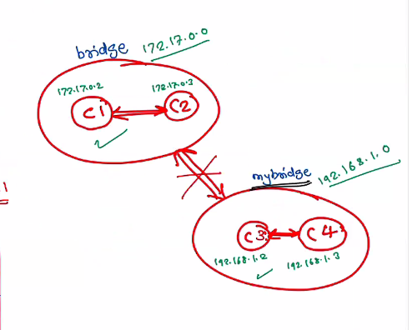

Containers in different networks will not be able to talk to each other

* In custom address by default a DNS entries in DNS table for communication.
* 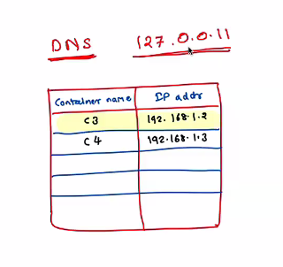
* DNS will only be used for custom network and not default/bridge network.
* To disconnect a ceontianer from one n/w or bridge to another customer n/w
* docker network disconnect bridge c1
* docker network connect mybridge c1
* 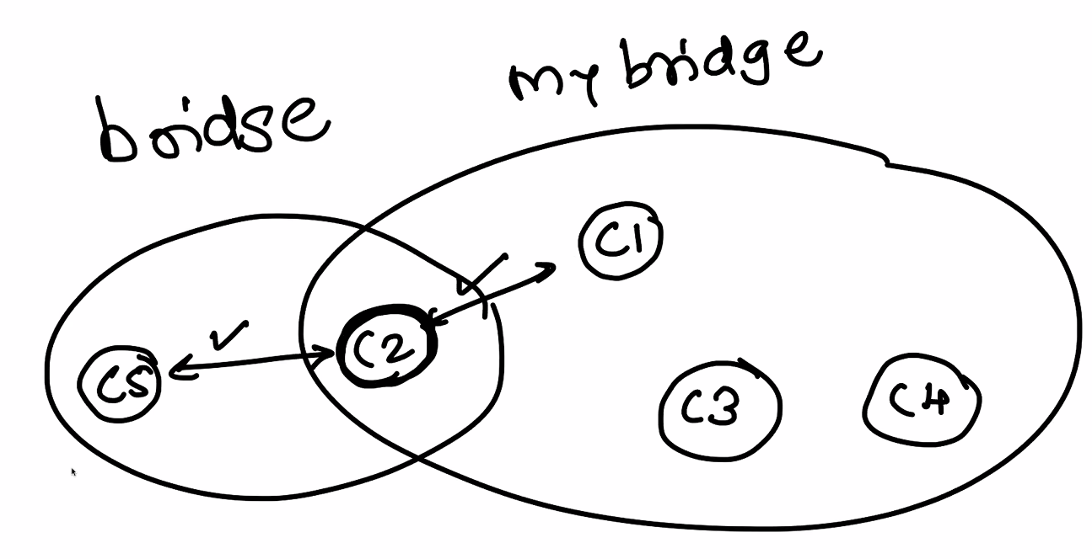
* We can connect c2 to mybridge so that contianers outside the network will be able to talk to containers in mybridge through c2.

**HOST NETWORK**

* 
 